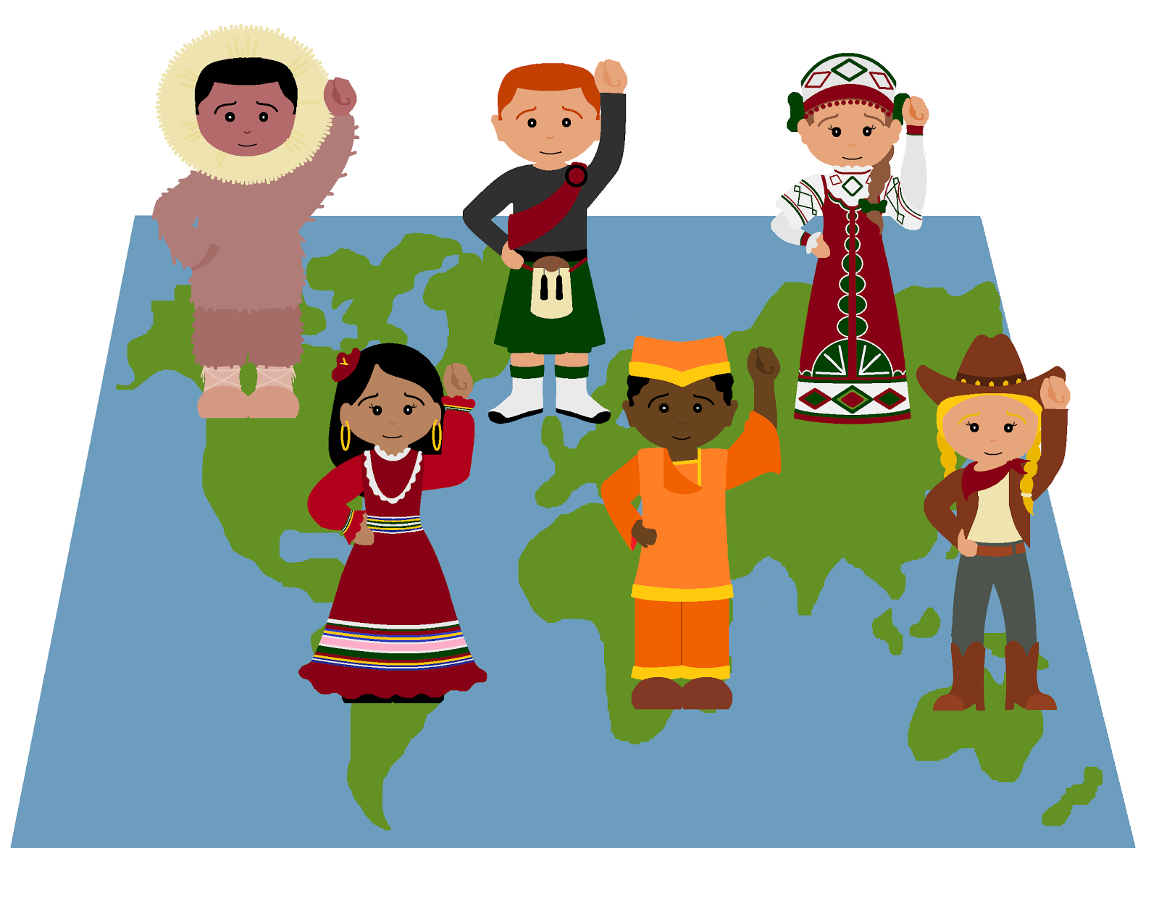

2017 Bala House
Weekly Camp Themes
“Around the World in 40 Days”

Week 1: Antarctica We will grab our mittens and hop on snowmobiles, as we travel throughout Antarctica, where 90% of the continent is covered by ice! Our campers will explore the South Pole and say hello to penguins, seals, and killer whales. Arctic treats will be waiting for us at the conclusion of our exploration of this frozen continent!
Week 2: Africa While venturing through the east African savannah, the tropical forest of the Congo, and the Sahara Desert, your child will create a tribal mask and desert sand art before going on a safari. We will be joined by a storyteller and hear the beats of traditional African drumming. It’s sure to be a wild ride!
Week 3: North America Hiking over mountains, across deserts, and through forests, we will take in the vast terrains of North America! This journey will open your child’s eyes to wonderful wildlife, from southern alligators to northern buffalo. They will also learn about captivating cultures, sample various cuisines, and try their hands at Native American painting! The week will wrap up with our annual 4th of July parade.
Week 4: South America Our young friends will create beautiful textile art, learn about Amazon wildlife, and imagine they are South American soccer stars while exploring the glacial lakes of Argentina, the rainforest of Brazil, and the mountains of Chile. They will taste tostones (fried plantain patties), listen to Latin American folktales, and learn a few Spanish phrases along the way. This will be an expedition your child will never forget!
Week 5: Asia We will travel by horse, bus, and train to collect various textiles, spices and art found in the world’s largest continent, Asia! From the windy mountains of Mongolia to the humid jungles of India, we will expand our palates while sampling Japanese, Chinese and Thai cuisine with chopsticks.
Week 6: Europe Campers will experience the many cultures of Europe. They will quickly move their feet while learning Irish dancing, have a go at baking a French baguette, join in some fun Romanian schoolyard games, and sample Mediterranean snacks. We will learn about the monumental architecture found all across Europe and even try our hands at painting on canvas like famed artist George Seurat.
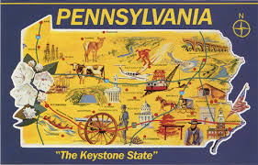
Week 7: Australia (Oceania) We are going down under to explore the
Great Barrier Reef, the desert and the beaches of Oceania. Our young
friends will make Australian boomerangs and explore the outback before
hopping the Pacific islands to learn about marsupials, komodo dragons
and the birds of New Guinea.

Week 8: There's no place like home! (Pennsylvania)
After a summer of globetrotting, we will head back home to Pennsylvania,
the Keystone State. Campers will learn about our local history, community,
and environment. They will make maps, draw self-portraits, and learn
about the plants, people, and animals that make PA, PA.

